Year 10 Source Analysis Practice
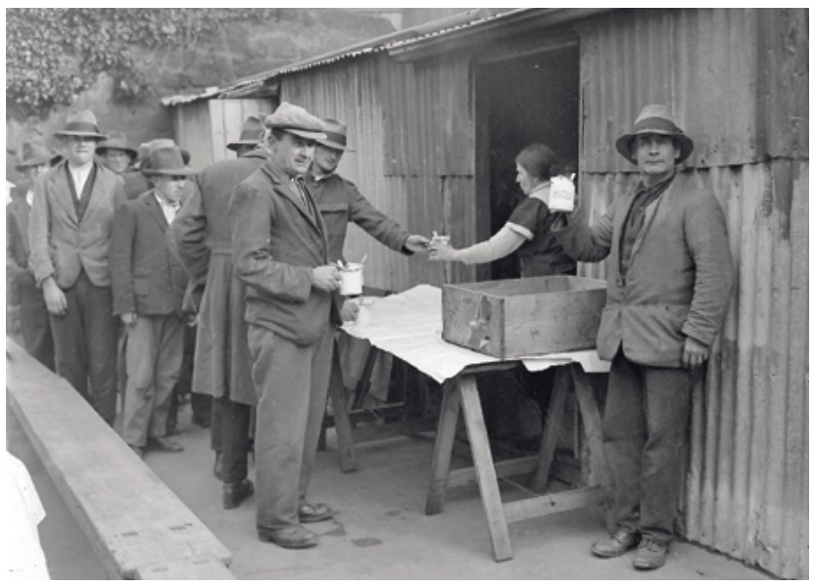
Source 1
A line of men receiving food handouts during the Great Depression in Australia in the 1930s
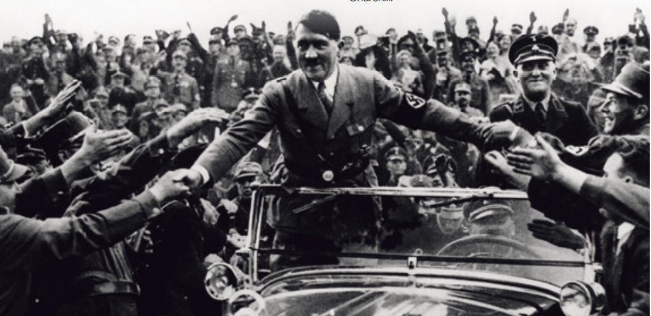
Source 2
Adolf Hitler and the Nazi Party rose to power in Germany during the 1930s by rallying the support of the German people. Hitler was a charismatic and gifted public speaker who promised to restore Germany’s reputation as a strong and proud nation after the economic hardships of the post-World War I era.
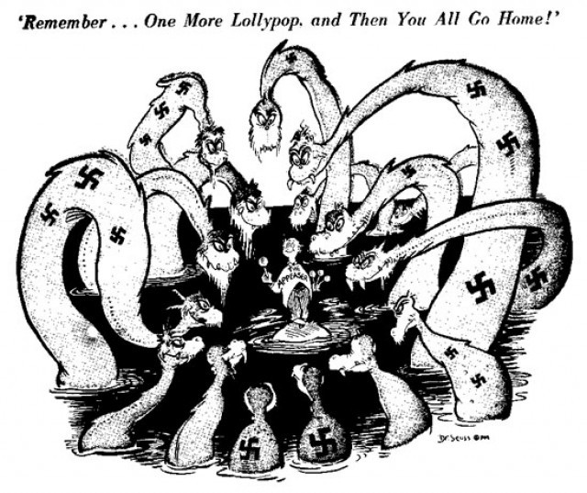

Source 3
Cartoon reflecting the Policy of Appeasement in Europe during the early days of Hitler’s rule.
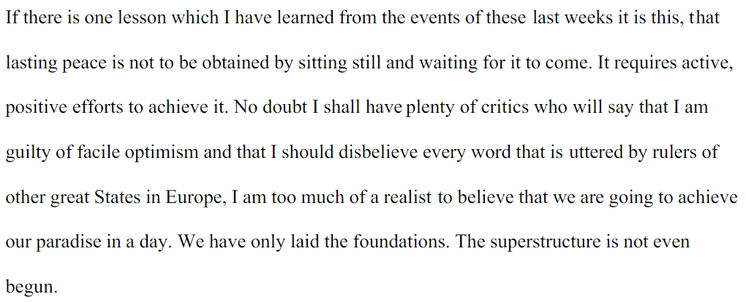

Source 4
Winston Churchill, British Prime Minister, on his thoughts about the Policy of Appeasement in 1939.

